**Temperature & Heating Degree Days**

By convention (according to the inter-webs), a base temperature of 60 – 65 oF is used to determine heating and cooling degree days. Slightly different values seem better suited to Princeton – the better fitting lines cross zero at 60 oF (heating) and at 55 oF (cooling). When the number of degree days is small the data gets a bit noisy – probably since average monthly temperatures masks higher daily variation in mild weather.

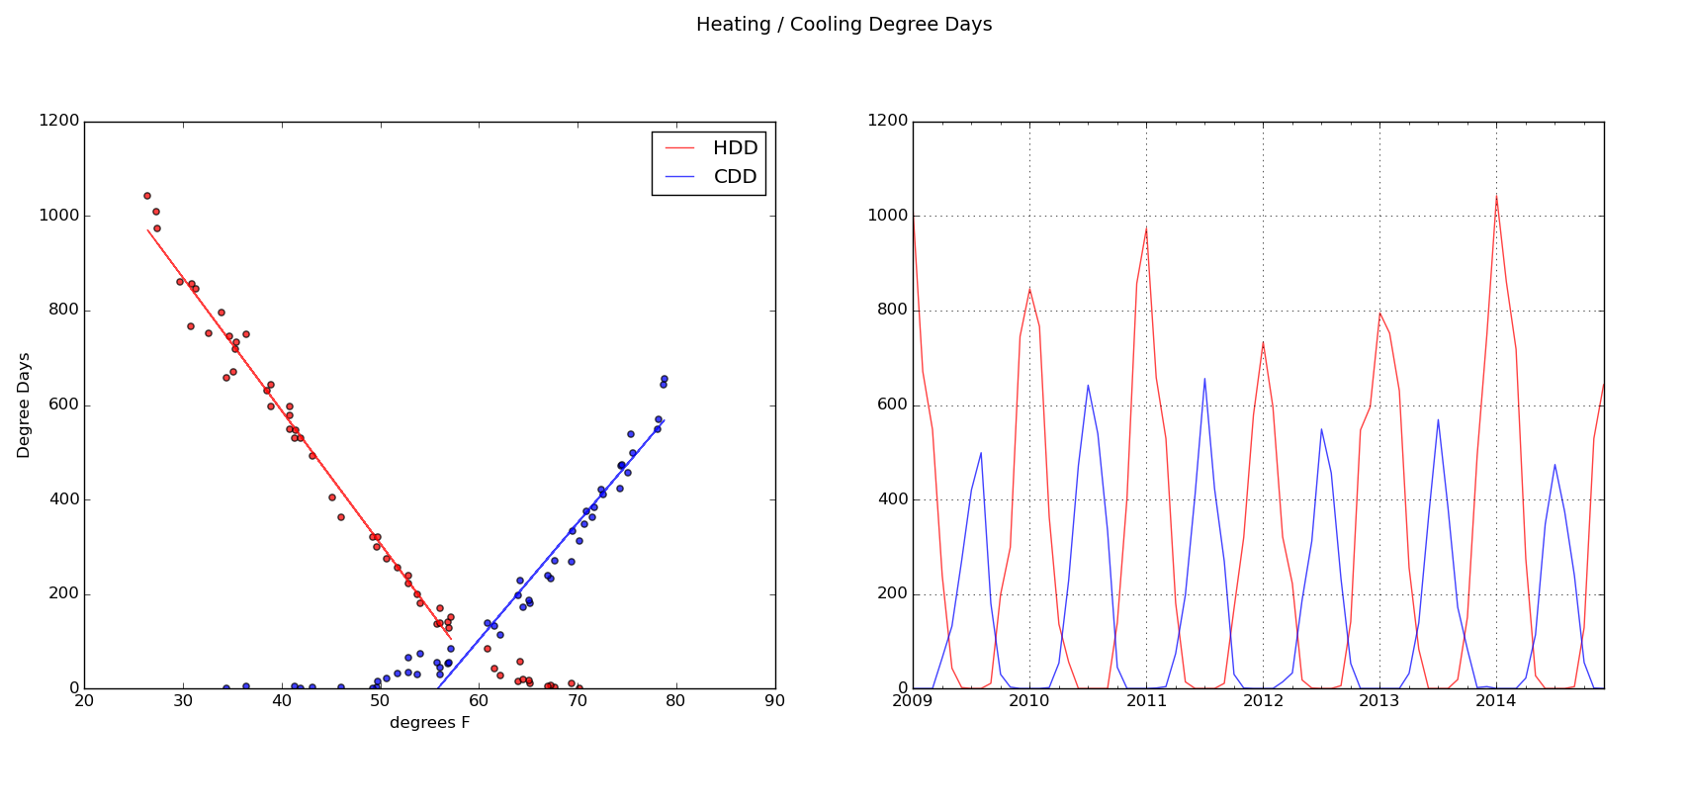

Sources:

Heating / cooling degree days: <http://weatherdatadepot.com/>

Historical monthly temperature: <http://climate.rutgers.edu/stateclim_v1/data/njhisttemp.html>

**Town & Borough**

Comparative plots vs time and temperature highlight the lower residential and higher commercial usage in the boro. Comparing residential meter counts to 2010 census data:

|  |  |  |  |  |  |  |
| --- | --- | --- | --- | --- | --- | --- |
|  | Housing Units  (2010 Census) | Electricity  Meters  (12/2010 PSE&G) | Gas  Meters  (12/2010 PSE&G) | Population | Population  Density |  |
| Boro | 3,488 | 3,871 | 3,047 | 12,307 | 1,825 |  |
| Town | 6,814 | 5,955 | 4,846 | 16,265 | 423 |  |

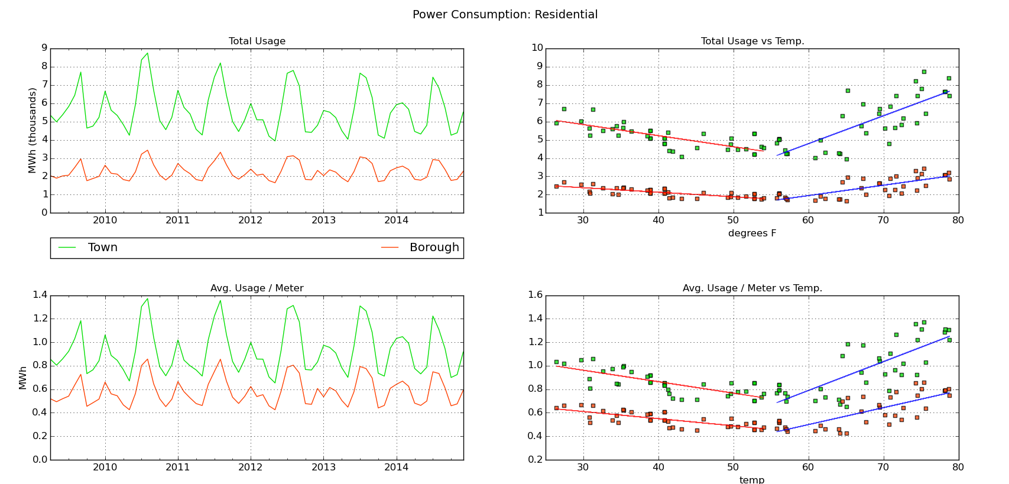

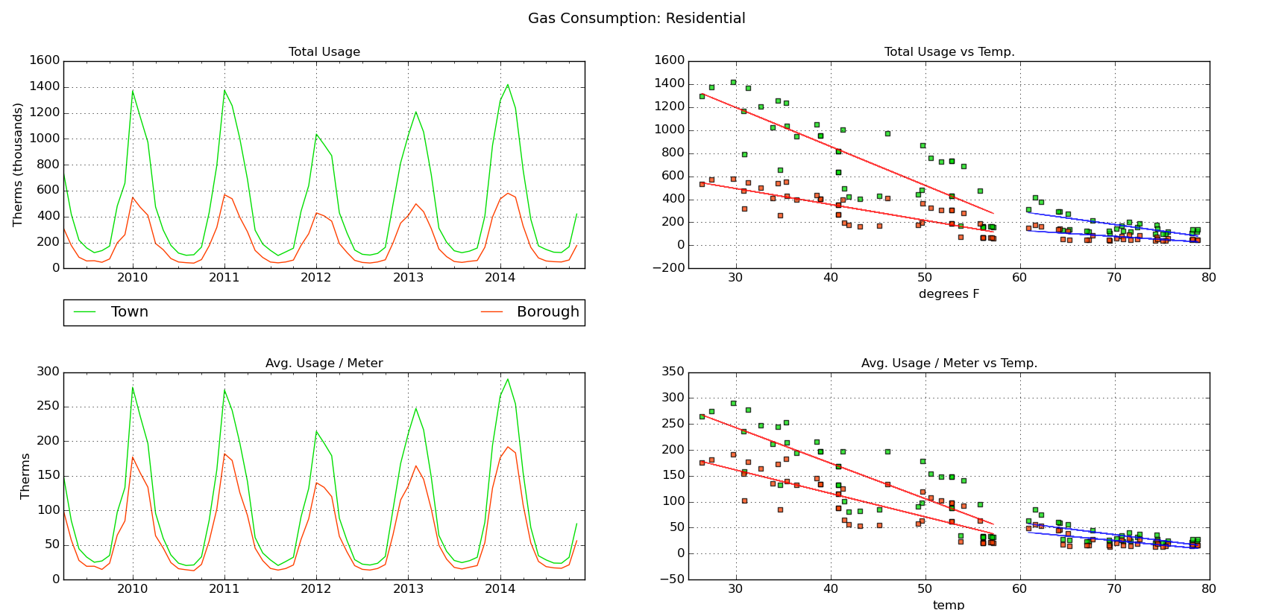

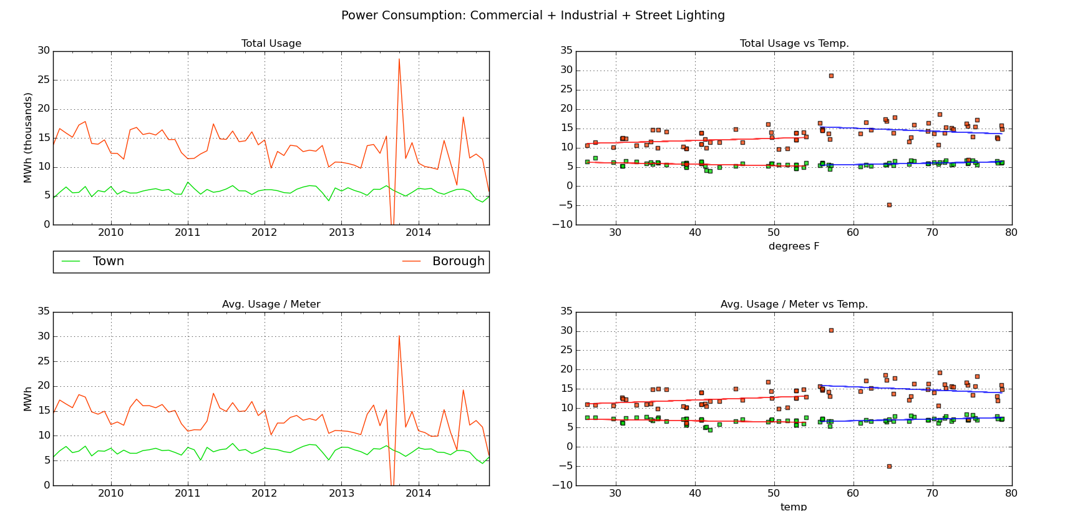

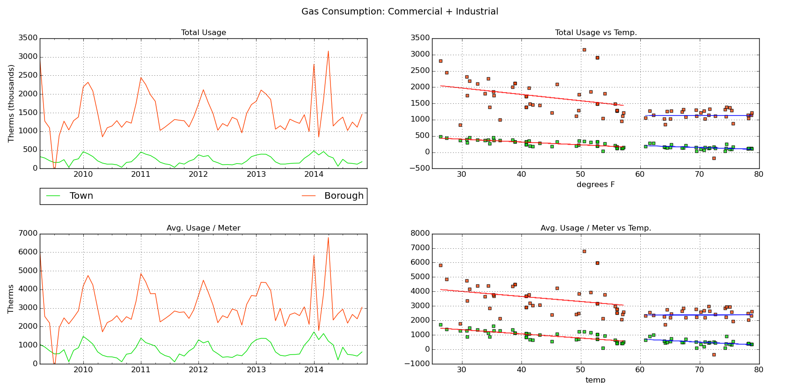

Energy use responds to temperature roughly linearly, which suggests a linear model of he form:

usage = base load + h * heating degree days + c * cooling degree days

Which can be visualized in a “you are here” plot. High values on either axes are “bad” in that they mean higher consumption for each degree day increase. The are of a bubble indicates base load.

The larger bubbles are the Commercial + Industrial category and are distinguished by the dark borders. Finally, regression outputs are listed – the fits are not great, but will do for visualization.

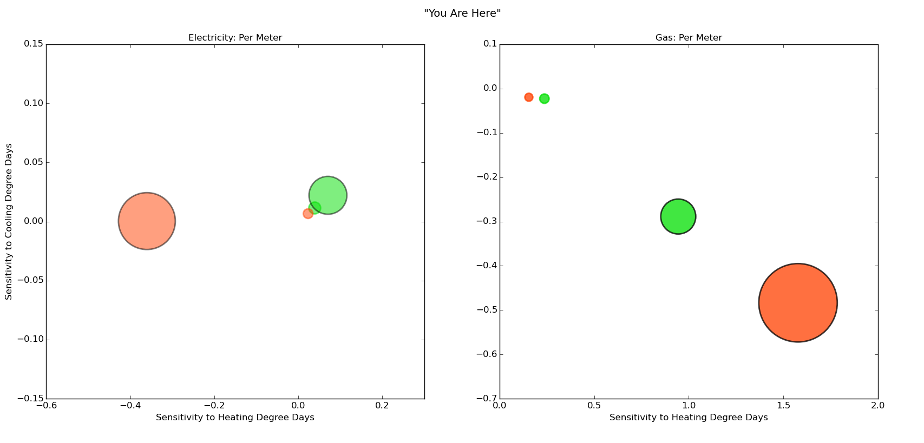

**Per Meter Regressions**

**Electricity: TWP Residential**

-----------------------Estimated Coefficients-----------------------------------

Variable Coef Std Err t-stat p-value CI 2.5% CI 97.5%

--------------------------------------------------------------------------------

HDD 0.0004 0.0001 5.96 0.0000 0.0003 0.0005

CDD 0.0011 0.0001 10.67 0.0000 0.0009 0.0014

intercept 0.6285 0.0377 16.69 0.0000 0.5547 0.7024

R-squared: 0.6788 Adj R-squared: 0.6675

**Electricity: BORO Residential**

-----------------------Summary of Estimated Coefficients------------------------

Variable Coef Std Err t-stat p-value CI 2.5% CI 97.5%

--------------------------------------------------------------------------------

HDD 0.0002 0.0000 5.57 0.0000 0.0002 0.0003

CDD 0.0007 0.0001 9.67 0.0000 0.0005 0.0008

intercept 0.4103 0.0241 17.00 0.0000 0.3630 0.4576

R-squared: 0.6320 Adj R-squared: 0.6191

**Electricity: TWP Commercial + Industrial + Street Lighting**

-----------------------Summary of Estimated Coefficients------------------------

Variable Coef Std Err t-stat p-value CI 2.5% CI 97.5%

--------------------------------------------------------------------------------

HDD 0.0007 0.0004 1.72 0.0908 -0.0001 0.0015

CDD 0.0022 0.0007 3.31 0.0016 0.0009 0.0035

intercept 6.3650 0.2350 27.08 0.0000 5.9044 6.8257

R-squared: 0.1731 Adj R-squared: 0.1441

**Electricity: BORO Commercial + Industrial + Street Lighting**

-----------------------Summary of Estimated Coefficients------------------------

Variable Coef Std Err t-stat p-value CI 2.5% CI 97.5%

--------------------------------------------------------------------------------

HDD -0.0036 0.0023 -1.54 0.1292 -0.0082 0.0010

CDD 0.0000 0.0038 0.01 0.9924 -0.0074 0.0075

intercept 14.3125 1.3358 10.71 0.0000 11.6944 16.9306

R-squared: 0.0812 Adj R-squared: 0.0489

**Gas: TWP Residential**

-----------------------Summary of Estimated Coefficients------------------------

Variable Coef Std Err t-stat p-value CI 2.5% CI 97.5%

--------------------------------------------------------------------------------

HDD 0.2360 0.0208 11.34 0.0000 0.1952 0.2768

CDD -0.0227 0.0337 -0.67 0.5028 -0.0888 0.0433

intercept 38.6897 11.8354 3.27 0.0018 15.4924 61.8871

R-squared: 0.8389 Adj R-squared: 0.8332

**Gas: PRINCETON BORO Residential**

-----------------------Summary of Estimated Coefficients------------------------

Variable Coef Std Err t-stat p-value CI 2.5% CI 97.5%

--------------------------------------------------------------------------------

HDD 0.1537 0.0146 10.52 0.0000 0.1251 0.1823

CDD -0.0195 0.0237 -0.83 0.4129 -0.0659 0.0268

intercept 28.0604 8.3046 3.38 0.0013 11.7834 44.3374

R-squared: 0.8217 Adj R-squared: 0.8154

**Gas: TWP Commercial + Industrial**

-----------------------Summary of Estimated Coefficients------------------------

Variable Coef Std Err t-stat p-value CI 2.5% CI 97.5%

--------------------------------------------------------------------------------

HDD 0.9442 0.1253 7.54 0.0000 0.6987 1.1897

CDD -0.2888 0.2028 -1.42 0.1601 -0.6863 0.1088

intercept 542.0172 71.2184 7.61 0.0000 402.4291 681.6053

R-squared: 0.7343 Adj R-squared: 0.7249

**Gas: BORO Commercial + Industrial**

-----------------------Summary of Estimated Coefficients------------------------

Variable Coef Std Err t-stat p-value CI 2.5% CI 97.5%

--------------------------------------------------------------------------------

HDD 1.5780 0.4725 3.34 0.0015 0.6518 2.5042

CDD -0.4835 0.7652 -0.63 0.5301 -1.9832 1.0163

intercept 2723.7919 268.6715 10.14 0.0000 2197.1958 3250.3881

R-squared: 0.3518 Adj R-squared: 0.3287

**Regressions of Aggregate Consumption**

**Electricity: TWP Residential**

-----------------------Summary of Estimated Coefficients------------------------

Variable Coef Std Err t-stat p-value CI 2.5% CI 97.5%

--------------------------------------------------------------------------------

HDD 2.4855 0.3938 6.31 0.0000 1.7136 3.2574

CDD 7.2339 0.6402 11.30 0.0000 5.9791 8.4886

intercept 3714.8522 224.7784 16.53 0.0000 3274.2866 4155.4178

R-squared: 0.7033 Adj R-squared: 0.6929

**Electricity: BORO Residential**

-----------------------Summary of Estimated Coefficients------------------------

Variable Coef Std Err t-stat p-value CI 2.5% CI 97.5%

--------------------------------------------------------------------------------

HDD 0.9278 0.1657 5.60 0.0000 0.6030 1.2525

CDD 2.6527 0.2694 9.85 0.0000 2.1248 3.1807

intercept 1585.0312 94.5784 16.76 0.0000 1399.6575 1770.4049

R-squared: 0.6414 Adj R-squared: 0.6289

**Electricity: TWP Commercial + Industrial + Street Lighting**

-----------------------Summary of Estimated Coefficients------------------------

Variable Coef Std Err t-stat p-value CI 2.5% CI 97.5%

--------------------------------------------------------------------------------

HDD 0.8804 0.3218 2.74 0.0083 0.2498 1.5111

CDD 2.1203 0.5230 4.05 0.0002 1.0952 3.1453

intercept 5221.3054 183.6393 28.43 0.0000 4861.3725 5581.2384

R-squared: 0.2247 Adj R-squared: 0.1975

**Electricity: BORO Commercial + Industrial + Street Lighting**

-----------------------Summary of Estimated Coefficients------------------------

Variable Coef Std Err t-stat p-value CI 2.5% CI 97.5%

--------------------------------------------------------------------------------

HDD -3.0804 2.2450 -1.37 0.1754 -7.4806 1.3198

CDD 0.4627 3.6491 0.13 0.8996 -6.6896 7.6150

intercept 13731.5694 1281.3064 10.72 0.0000 11220.2088 16242.9300

R-squared: 0.0736 Adj R-squared: 0.0411

**Gas: TWP Residential**

-----------------------Summary of Estimated Coefficients------------------------

Variable Coef Std Err t-stat p-value CI 2.5% CI 97.5%

--------------------------------------------------------------------------------

HDD 1161.7652 102.3517 11.35 0.0000 961.1558 1362.3746

CDD -108.2812 165.7356 -0.65 0.5162 -433.1229 216.5606

intercept 190223.5438 58193.8067 3.27 0.0018 76163.6828 304283.4049

R-squared: 0.8389 Adj R-squared: 0.8331

**Gas: BORO Residential**

-----------------------Summary of Estimated Coefficients------------------------

Variable Coef Std Err t-stat p-value CI 2.5% CI 97.5%

--------------------------------------------------------------------------------

HDD 469.8198 44.3576 10.59 0.0000 382.8789 556.7607

CDD -57.7859 71.8271 -0.80 0.4245 -198.5671 82.9952

intercept 85728.5335 25220.2503 3.40 0.0013 36296.8429 135160.2241

R-squared: 0.8231 Adj R-squared: 0.8168

**Gas: TWP** **Commercial + Industrial**

-----------------------Summary of Estimated Coefficients------------------------

Variable Coef Std Err t-stat p-value CI 2.5% CI 97.5%

--------------------------------------------------------------------------------

HDD 287.2078 34.2137 8.39 0.0000 220.1490 354.2666

CDD -75.1067 55.4013 -1.36 0.1806 -183.6933 33.4799

intercept 152260.6993 19452.7602 7.83 0.0000 114133.2893 190388.1093

R-squared: 0.7674 Adj R-squared: 0.7591

**Gas: BORO Commercial + Industrial**

-----------------------Summary of Estimated Coefficients------------------------

Variable Coef Std Err t-stat p-value CI 2.5% CI 97.5%

--------------------------------------------------------------------------------

HDD 877.4050 224.9157 3.90 0.0003 436.5703 1318.2397

CDD -151.3383 364.2003 -0.42 0.6793 -865.1708 562.4942

intercept 1252617.1417 127879.6029 9.80 0.0000 1001973.1200 1503261.1634

R-squared: 0.3974 Adj R-squared: 0.3758